
Films Database.
Assignment 2: Development of a .NET database solution
Antonio Calvo
sentinel_red@live.com
Table of Contents
Films Database Structure 2
Films Storyboard 3
Test Log 8
Test Plan 10

Table of Contents

Films Database Structure 3
Films Storyboard 4
Films Screen 4
Queries Screen 8
Help Screen 11

Appendix 38
Film Screen Code. 38
Queries Screen Code. 48
Help Screen Code. 53

What Cinema Application is:

Cinema Application will be connected a database which will allow to manage the data, make queries and SQL queries and also include a help page. In order to do that a Graphical User Interface is created and designed.

Films Database Structure

AUTHOR: Antonio Calvo |  | APPLICATION: Access |  |  | DATE: 07/03/2018
NAME OF ENTITY: Administration
Description:

This table holds films and the information about them.

ATTRIBUTES | LENGTH |  | TYPE | COMMENT
ID | 20 |  | AutoNumber | Primary Key.
FilmYear | 40 |  | Number | Field Size Long Integer  Decimal Places Auto
Length |  |  | Short Text | Field Size = 255
Title | 100 |  | Short Text | Field Size = 255
Subject |  |  | Short Text | Field Size = 255
ActorSurname |  |  | Short Text | Field Size = 255
ActorForename | 20 |  | Short Text | Field Size = 255
ActressSurname |  |  | Short Text | Field Size = 255
ActessForename |  |  | Short Text | Field Size = 255
DicretorSurname |  |  | Short Text | Field Size = 255
DirectorForename | 20 |  | Short text | Field Size = 255
Popularity | 20 |  | Short text | Field Size = 255
Awards
Any Relationships between entities?
This table does not hold any relationship.

Films Storyboard

Films Screen

Program Name: Films Info | Form /  Module Name: Films | Function of  Form Module: Navigation
Screen Shot:  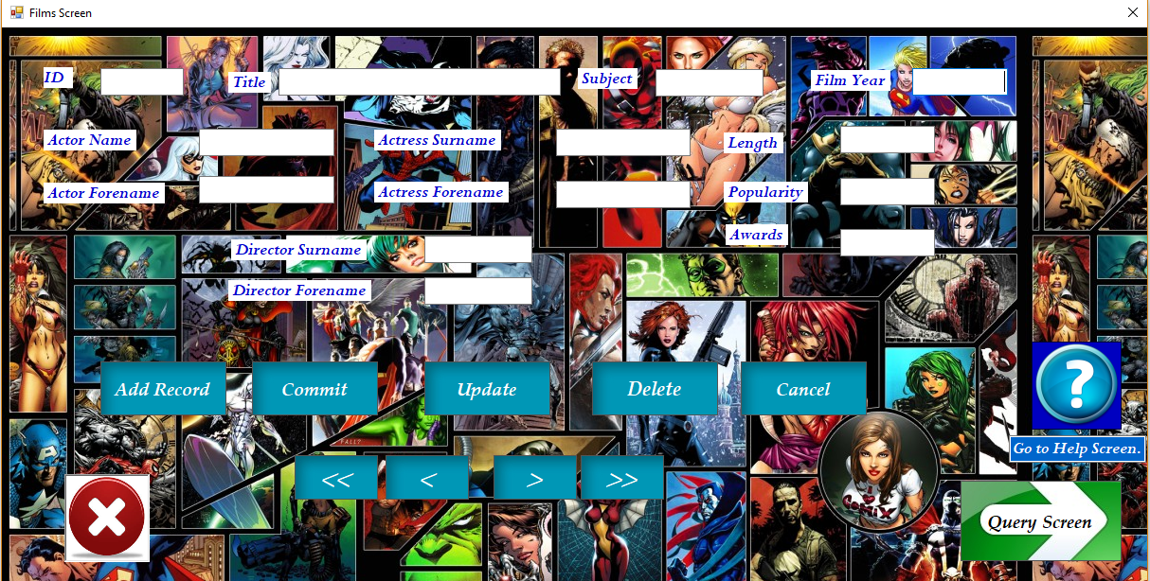 |  | Objects.  Lable1  Label2  Lable3  Lable4  Lable5  Lable6  Lable7  Lable8  Lable9  Lable10  Lable11  Lable12  Lable13  txtID  txtFilmYear  txtLength  txtTitle  txtSubject  txtActorSurname  txtActorForename  txtActressSurname  txtActressForename  txtDicrectorSurname  txtDirectorForename  txtPopularity  txtAwars  btnUpdate  btnCommit  btnAddRecord  btnDelete  btnCancel  btnPreviousRecord  btnFirstRecord  btnNextRecord  btnLastRecord  btnMoveForm  btnHelp  PictureBoxClose | Event.  None  None  None  None  None  None  None  None  None  None  None  None  None  None  None  None  None  None  None  None  None  None  None  None  None  None  Click  Click  Click  Click  Click  Click  Click  Click  Click  Click  Click  Click  Click | Description (Typical input/output)  Txt = ID  Txt = Film Year  Txt = Length  Txt = Title  Txt = Subject  Txt = Actor Surname  Txt = Actor Forename  Txt = Actress Surname  Txt = Actress Forename  Txt = Director Surname  Txt = Director Forename  Txt = Popularity  Txt = Awars  Txt = ID  Txt = ID  Txt = ID  Txt = ID  Button = Add Record (Set the form to add a new record)  Button = Commit (Add a new record)  Button = Update (Update de records.)  Button = Delete (Remove records)  Button = Cancel (Cancel the accion)  Button = Previous Record  Button = Next Record  Button = First Record  Button = Last Record  Button = Query Form  Button = Close (Close the application.)  Button = Help (Pop the Help Screen.)
Additional Information: (fonts, pictures, colours)

- Lables Format: Perpetua, 14.25pt, style=Bold, Italic
Colour: Medium Blue
- Text boxes Format: Perpetua, 14.25pt, style=Bold, Italic
Colour: White
- Buttons Format: Palatino Linotype, 14.25pt, style=Bold, Italic.
Picture background System Drawing. Bitmap
- Navigation Button Format: Palatino Linotype, 14.25pt, style=Bold, Italic.
Picture background System Drawing. Bitmap
- Close button: Background picture.
- Queries button: Background picture.
- Form Format: Picture background System Drawing. Bitmap

Queries Screen

Program Name: Films Info | Form /  Module Name: Queries Screen | Function of  Form Module: Build and Run Queries
Screen Shot:  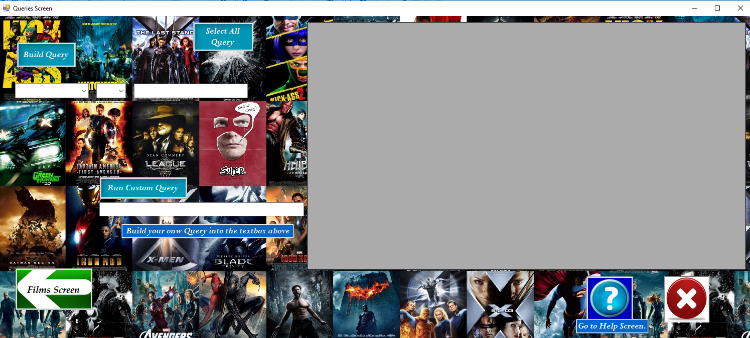 |  | Objects.  cboField  cboOperator  txtSQL  txtValue  txtInfo  txtInfoHelp  btnSelectQuery  btnBuiltQuery  btnFilms  btnHelp  PictureboxClose2  DataGridView1 | Event.  Click  Click  None  None  None  None  Click  Click  Click  Click  Click  None | Description (Typical input/output)  cboField = Display fields from database  cboOperator= Display math operators.  txtSQL = type the record you are looking for  txtValue = type your Query in a SQL language.  txtInfo = Show help Info  txtInfoHelp = Show help Info.  btnSelectQuery = Display the database into DataGridView  btnBuiltQuery = Run the Query have been built.  btnFilms = Run the Query  btnHelp = Take the user to help Screen  PictureboxClose2 = Close de application.  DataGridView1 = Display the information from database.
Additional Information: (fonts, pictures, colours)

- Buttons Format: Palatino Linotype, 14.25pt, style=Bold, Italic.
Picture background System Drawing. Bitmap
- PictureboxClose2 = System.Drawing.Bitmap
- Combo box Format = Perpetua, 14.25pt, style=Bold, Italic
- Form Format: Picture background System Drawing. Bitmap
- Txt Info and txtInfo Help text boxes Format: Perpetua, 14.25pt, style=Bold, Italic
Colour = Hot Track.

Help Screen

Program Name: Films Info | Form /  Module Name: Films | Function of  Form Module: Navigation
Screen Shot:  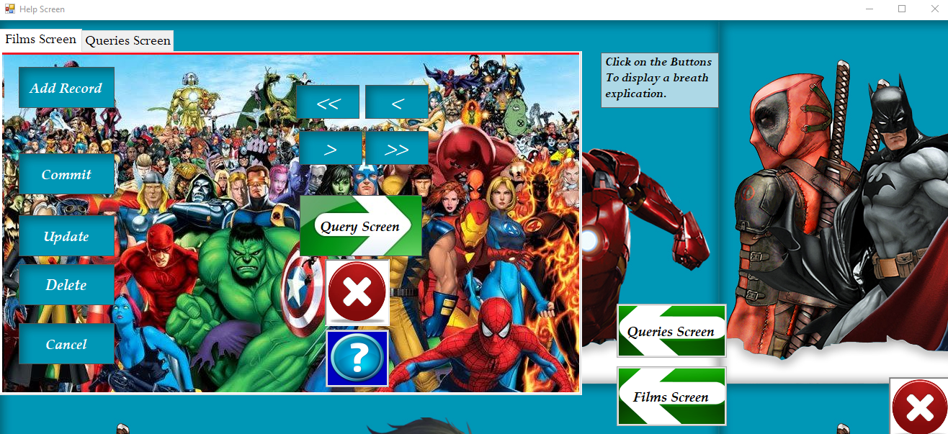  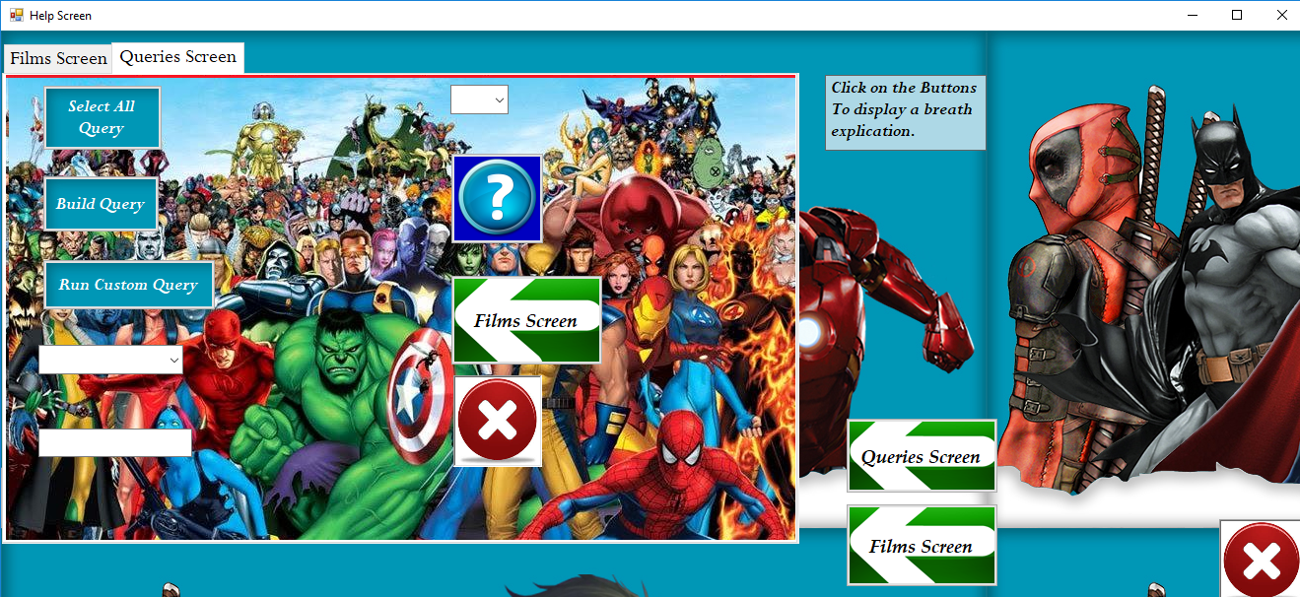 |  | Objects.  Tab Control  Tab 1 (Films Screen)  - Update button  - Commit Button  - Add Record button  - Delete button  - Cancel Button  - First Record button  - Previous button  - Last Record button  - Next Record button  - Query Screen button  - Close button  - Ten Text boxes  - Background picture.  Tab 2  - Select All Query button  - Build Query button  - Run Custom Query button  - Films Screen Button  - Help Button  - PictureBox3  - Field Combo Box  - Operator Combo box  - Field Combo box  - txtValue text box.  - 9 Text box.  - Background picture.  Displayed on the form.  One text box  Queries button  Close button | Event.  Click  Click  Click  Click  Click  Click  Click  Click  Click  Click  Click  Click  Click  Click  Click  Click  Click | Description (Typical input/output)  Tab Control  Tab 1 (Films Screen)  Add Record = Display a text box.  Commit = Display a text box.  Update = Display a text box.  Delete = Display a text box.  Cancel = Display a text box.  Previous Record = Display a text box.  Next Record = Display a text box.  First Record = Display a text box.  Last Record = Display a text box.  Query Form = Display a text box.  Close = Display a text box.  Nine text boxes: Each one displays a breath information about the functionality of the buttons.  Tab 2 (Queries Screen)  Select All Query button = Display a text box.  Build Query button = Display a text box  Run Custom Query button = Display a text box  Films Screen button = Display a text box.  Help Button = Display a text box  PictureBox3 = Display a text box.  Operator Combo box = Display a operator.  txtValue = Display a operator.  The Nine text boxes = Each one displays a breath information about the functionality of the buttons.  Displayed on the form:  - One text box which explain how to use Help Screen  - Films Screen = Take the user to Films Screen.  - Queries button = Take the user to Queries Screen  - Close button which close the application.
Additional Information: (fonts, pictures, colours)
- Tab 1
- buttons Format: Perpetua, 14.25pt, style=Bold, Italic
Background picture: Medium Blue
Close button: Background picture.
Close button: Background picture.
- Text boxes Format: Perpetua, 14.25pt, style=Bold, Italic
Colour: White
- Tab 2
- buttons Format: Perpetua, 14.25pt, style=Bold, Italic
Background picture: Medium Blue
Close button: Background picture.
- Text boxes Format: Perpetua, 14.25pt, style=Bold, Italic
Colour: White

- Form:
- Queries Screen and Films Screen buttons: Background picture
- Close button: Background picture.
- Form Format: Picture background System Drawing. Bitmap

Appendix

Film Screen Code.

Public Class Form1

'Global variables.

'used to store rows in the dataSet
Dim inc As Integer
Dim MaxRows As Integer

'Variable con will hold the connection Object.
'Aslo creating a new object which is used to connect to an Access database
Dim con As New OleDb.OleDbConnection

'Provider and Data Source used to specify where is the database.
Dim dbProvider As String
Dim dbSource As String

Dim Sql As String

'Create a dataset.
Dim ds As New DataSet

'it hold a reference to the data adapter.
Dim da As OleDb.OleDbDataAdapter

Private Sub Form1_Load (sender As Object, e As EventArgs) Handles MyBase.Load

'Create a new data adapter object
da = New OleDb.OleDbDataAdapter(Sql, con)

'Technology to connect VB with a data base
dbProvider = "PROVIDER=Microsoft.Jet.OLEDB.4.0;"

'Where is the code.
dbSource = "Data Source=|DATADIRECTORY|films2000.mdb"

con.ConnectionString = dbProvider & dbSource

'It open the database
con.Open()

da = New OleDb.OleDbDataAdapter(Sql, con)

Sql = "SELECT * FROM tblFilms"
da = New OleDb.OleDbDataAdapter(Sql, con)

'Used ti fill with the records selected from the table.
da.Fill(ds, "films2000")

con.Close()

MaxRows = ds.Tables("films2000").Rows.Count
inc = -1

End Sub

Private Sub NavigateRecords()

'Using try and Catch the program won't break when there is a null field.
Try
txtID.Text = ds.Tables("films2000").Rows(inc).Item("ID")

Catch ex As Exception
txtID.Text = ""
txtID.Clear()
End Try

Try
txtFilmYear.Text = ds.Tables("films2000").Rows(inc).Item("FilmYear")

Catch ex As Exception
txtFilmYear.Text = ""
txtFilmYear.Clear()
End Try

Try

txtLength.Text = ds.Tables("films2000").Rows(inc).Item("Length")

Catch ex As Exception

txtLength.Text = ""
txtLength.Clear()

End Try

Try
txtTitle.Text = ds.Tables("films2000").Rows(inc).Item("Title")

Catch ex As Exception
txtTitle.Text = ""
txtTitle.Clear()
End Try

Try
txtSubject.Text = ds.Tables("films2000").Rows(inc).Item("Subject")

Catch ex As Exception
txtSubject.Text = ""
txtSubject.Clear()

End Try

Try
txtActorSurname.Text = ds.Tables("films2000").Rows(inc).Item("ActorSurname")

Catch ex As Exception
txtActorSurname.Text = ""
txtActorSurname.Clear()

End Try

Try
txtActorForename.Text = ds.Tables("films2000").Rows(inc).Item("ActorForename")

Catch ex As Exception
txtActorForename.Text = ""
txtActorForename.Clear()

End Try

Try
txtActressSurname.Text = ds.Tables("films2000").Rows(inc).Item("ActressSurname")

Catch ex As Exception
txtActressSurname.Text = ""
txtActressSurname.Clear()

End Try

Try
txtActressForename.Text = ds.Tables("films2000").Rows(inc).Item("ActressForename")

Catch ex As Exception
txtActressForename.Text = ""
txtActressForename.Clear()

End Try

Try
txtDirectorSurname.Text = ds.Tables("films2000").Rows(inc).Item("DirectorSurname")

Catch ex As Exception

txtDirectorSurname.Text = ""
txtDirectorSurname.Clear()

End Try

Try

txtDirectorForename.Text = ds.Tables("films2000").Rows(inc).Item("DirectorForename")

Catch ex As Exception
txtDirectorForename.Text = ""
txtDirectorForename.Clear()

End Try

Try

txtPopularity.Text = ds.Tables("films2000").Rows(inc).Item("Popularity")

Catch ex As Exception
txtPopularity.Text = ""
txtPopularity.Clear()

End Try

Try

txtAwards.Text = ds.Tables("films2000").Rows(inc).Item("Awards")

Catch ex As Exception
txtAwards.Text = ""
txtAwards.Clear()

End Try

End Sub

Private Sub btnUpdate_Click(sender As Object, e As EventArgs) Handles btnUpdate.Click

Dim cb As New OleDb.OleDbCommandBuilder(da)
'Declaring i variable
Dim i As String = ""

'if Used to dont break the program when the table is updating.

If txtID.Text Like i Then

Else
ds.Tables("films2000").Rows(inc).Item("ID") = txtID.Text
ds.Tables("films2000").Rows(inc).Item("FilmYear") = txtFilmYear.Text

ds.Tables("films2000").Rows(inc).Item("Length") = txtLength.Text
ds.Tables("films2000").Rows(inc).Item("Title") = txtTitle.Text
ds.Tables("films2000").Rows(inc).Item("Subject") = txtSubject.Text
ds.Tables("films2000").Rows(inc).Item("ActorSurname") = txtActorSurname.Text

ds.Tables("films2000").Rows(inc).Item("ActorForename") = txtActorForename.Text

ds.Tables("films2000").Rows(inc).Item("ActressSurname") = txtActressSurname.Text

ds.Tables("films2000").Rows(inc).Item("ActressForename") = txtActressForename.Text

ds.Tables("films2000").Rows(inc).Item("DirectorSurname") = txtDirectorSurname.Text

ds.Tables("films2000").Rows(inc).Item("DirectorForename") = txtDirectorForename.Text

ds.Tables("films2000").Rows(inc).Item("Popularity") = txtPopularity.Text
ds.Tables("films2000").Rows(inc).Item("Awards") = txtAwards.Text

da.Update(ds, "films2000")

MsgBox("Data updated")
End If

End Sub

Private Sub btnPreviousRecord_Click(sender As Object, e As EventArgs) Handles btnPreviousRecord.Click

'Used to navigate through the records and set a message box if there is not previous record entered.
If inc > 0 Then
inc = inc - 1
NavigateRecords()
ElseIf inc = -1 Then
MsgBox("No Records Yet")
ElseIf inc = 0 Then
MsgBox("First Record")
End If

End Sub

Private Sub btnFirstRecord_Click(sender As Object, e As EventArgs) Handles btnFirstRecord.Click

'
If inc <> 0 Then
inc = 0
NavigateRecords()
End If

End Sub

Private Sub btnNextRecord_Click(sender As Object, e As EventArgs) Handles btnNextRecord.Click

If inc <> MaxRows - 1 Then
inc = inc + 1
NavigateRecords()
Else
MsgBox("No More Rows")
End If

End Sub

Private Sub btnLastRecord_Click(sender As Object, e As EventArgs) Handles btnLastRecord.Click

If inc <> MaxRows - 1 Then
inc = MaxRows - 1
NavigateRecords()

End If

End Sub

Private Sub btnAddNew_Click(sender As Object, e As EventArgs) Handles btnAddNew.Click

'Anable or Unable buttons

btnCommit.Enabled = True
btnAddNew.Enabled = False
btnUpdate.Enabled = False
btnDelete.Enabled = False

'Clean the fields from data to add the new record
txtID.Clear()
txtFilmYear.Clear()
txtLength.Clear()
txtTitle.Clear()
txtSubject.Clear()
txtActorSurname.Clear()
txtActorForename.Clear()
txtActressSurname.Clear()
txtActressForename.Clear()
txtDirectorSurname.Clear()
txtDirectorForename.Clear()
txtPopularity.Clear()
txtAwards.Clear()

End Sub

Private Sub btnCommit_Click(sender As Object, e As EventArgs) Handles btnCommit.Click

'The first line if tell me if there is a valid record to add.
If inc <> -1 Then
Dim cb As New OleDb.OleDbCommandBuilder(da)

'to create a new row in database to add the new data
Dim dsNewRow As DataRow

dsNewRow = ds.Tables("films2000").NewRow()

'txtTitle is the unique field is required when you enter a new data in the database.
'This if is used for that purpose.
Dim i As String = ""

If txtFilmYear.Text Like i Then

MsgBox("Film Title is required ")
txtFilmYear.Clear()

Else

dsNewRow.Item("FilmYear") = txtFilmYear.Text
dsNewRow.Item("Length") = txtLength.Text
dsNewRow.Item("Title") = txtTitle.Text
dsNewRow.Item("Subject") = txtSubject.Text
dsNewRow.Item("ActorSurname") = txtActorSurname.Text
dsNewRow.Item("ActorForename") = txtActorForename.Text
dsNewRow.Item("ActressSurname") = txtActressSurname.Text
dsNewRow.Item("ActressForename") = txtActressForename.Text
dsNewRow.Item("DirectorSurname") = txtDirectorSurname.Text
dsNewRow.Item("DirectorForename") = txtDirectorForename.Text
dsNewRow.Item("Popularity") = txtPopularity.Text
dsNewRow.Item("Awards") = txtAwards.Text

ds.Tables("films2000").Rows.Add(dsNewRow)
da.Update(ds, "films2000")
MsgBox("New Record added to the Database")

End If

btnCommit.Enabled = False
btnAddNew.Enabled = True
btnUpdate.Enabled = True
btnDelete.Enabled = True

End If

End Sub

Private Sub btnDelete_Click(sender As Object, e As EventArgs) Handles btnDelete.Click

Dim i As String = ""

' When there is not any data entered to delete a msgbox will be displayed
If txtID.Text Like i Then
MsgBox("Not record to delete entered yet")

'Display a question do you want to delete it? Answer No - Cancel operation

ElseIf MessageBox.Show("Do you really want to Delete this Record?", "Delete", MessageBoxButtons.YesNo, MessageBoxIcon.Warning) = DialogResult.No Then
MsgBox("Operation Cancelled")
Exit Sub

'Answer yes delete it.
Else
Dim cb As New OleDb.OleDbCommandBuilder(da)

ds.Tables("films2000").Rows(inc).Delete()
MaxRows = MaxRows - 1
inc = 0
da.Update(ds, "films2000")
NavigateRecords()

End If

End Sub

Private Sub btnQuery_Click(sender As Object, e As EventArgs) Handles btnQuery.Click

Me.Hide()
Form2.Show()

End Sub

Private Sub txtFilmYear_TextChanged(sender As Object, e As EventArgs) Handles txtFilmYear.TextChanged

'Avoid letter from FilmYear
Dim i As String = "[a-z]"

If txtFilmYear.Text Like i Then

MsgBox("No Number Allowed, Only Letters")
txtFilmYear.Clear()

End If

End Sub

Private Sub btnClear_Click(sender As Object, e As EventArgs) Handles btnClear.Click

btnCommit.Enabled = False
btnAddNew.Enabled = True
btnUpdate.Enabled = True
btnDelete.Enabled = True
inc = 0
NavigateRecords()

End Sub

Private Sub PictureBox1_Click(sender As Object, e As EventArgs) Handles PictureBox1.Click

'Close the program
Me.Close()

End Sub

Private Sub btnHelp_Click(sender As Object, e As EventArgs) Handles btnHelp.Click

'Hide that form and open the specific form
Me.Hide()
Form3.Show()

End Sub
End Class

Queries Screen Code.

Public Class Form2

Dim Query As String

Private Sub btnSelectQuery_Click(sender As Object, e As EventArgs) Handles btnSelectQuery.Click

Dim con As New OleDb.OleDbConnection
Dim dbProvider As String
Dim dbSource As String
Dim ds As New DataSet
Dim da As OleDb.OleDbDataAdapter
Dim sql As String
Dim Count As Integer

dbProvider = "PROVIDER=Microsoft.Jet.OLEDB.4.0;"

dbSource = "Data Source=|DATADIRECTORY|films2000.mdb"

con.ConnectionString = dbProvider & dbSource

con.Open()

sql = "SELECT * FROM tblFilms"
da = New OleDb.OleDbDataAdapter(sql, con)

da.Fill(ds, "Table") 'Fill the dataset, ds, with the SELECT
Count = ds.Tables("Table").Rows.Count
DataGridView1.DataSource = ds.Tables(0)
con.Close()

End Sub

Private Sub btnRun_Click(sender As Object, e As EventArgs) Handles btnRun.Click

Dim con As New OleDb.OleDbConnection
Dim dbProvider As String
Dim dbSource As String
Dim ds As New DataSet
Dim da As OleDb.OleDbDataAdapter
Dim sql As String
Dim Count As Integer

dbProvider = "PROVIDER=Microsoft.Jet.OLEDB.4.0;"

dbSource = "Data Source=|DATADIRECTORY|films2000.mdb"

con.ConnectionString = dbProvider & dbSource

'Try and catch used to don’t break the program in case, the query is not well built
Try
con.Open()

sql = txtSQL.Text 'take text from text box
da = New OleDb.OleDbDataAdapter(sql, con)

da.Fill(ds, "Table") 'Fill the dataset, ds, with the statement
Count = ds.Tables("Table").Rows.Count
DataGridView1.DataSource = ds.Tables(0)

Catch ex As Exception
MsgBox("SQL no valid")

End Try

con.Close()

End Sub

Private Sub Button1_Click(sender As Object, e As EventArgs)

Me.Hide()
Form1.Show()

End Sub

Private Sub btnBuiltQuery_Click(sender As Object, e As EventArgs) Handles btnBuiltQuery.Click

Dim con As New OleDb.OleDbConnection
Dim dbProvider As String
Dim dbSource As String
Dim ds As New DataSet
Dim da As OleDb.OleDbDataAdapter
Dim Count As Integer

dbProvider = "PROVIDER=Microsoft.Jet.OLEDB.4.0;"

dbSource = "Data Source=|DATADIRECTORY|films2000.mdb"

con.ConnectionString = dbProvider & dbSource

con.Open()

txtSQL.Text = ""

'When the query is not build correctly pop the message.

If cboField.Text = "" Or cboOperator.Text = "" Then
MsgBox("You must select a field or operator to search from")
Exit Sub
End If

'Set up start of query string
Query = "Select * from tblFilms Where "

If cboField.Text = "FilmYear" Then
Query = Query & cboField.Text & " " & cboOperator.Text
'Not quotes for this line because FilmYear is number.
Query = Query & txtValue.Text

ElseIf cboField.Text = "Length" Then
Query = Query & cboField.Text & " " & cboOperator.Text
Query = Query & "'" & txtValue.Text & "'"

ElseIf cboField.Text = "Title" Then
Query = Query & cboField.Text & " " & cboOperator.Text
Query = Query & "'" & txtValue.Text & "'"

ElseIf cboField.Text = "Subject" Then
Query = Query & cboField.Text & " " & cboOperator.Text
Query = Query & "'" & txtValue.Text & "'"

ElseIf cboField.Text = "ActorSurname" Then
Query = Query & cboField.Text & " " & cboOperator.Text
Query = Query & "'" & txtValue.Text & "'"

ElseIf cboField.Text = "ActorForename" Then
Query = Query & cboField.Text & " " & cboOperator.Text
Query = Query & "'" & txtValue.Text & "'"

ElseIf cboField.Text = "ActressSurname" Then
Query = Query & cboField.Text & " " & cboOperator.Text
Query = Query & "'" & txtValue.Text & "'"

ElseIf cboField.Text = "ActressForename" Then
Query = Query & cboField.Text & " " & cboOperator.Text
Query = Query & "'" & txtValue.Text & "'"

ElseIf cboField.Text = "DirectorSurname" Then
Query = Query & cboField.Text & " " & cboOperator.Text
Query = Query & "'" & txtValue.Text & "'"

ElseIf cboField.Text = "DirectorForename" Then
Query = Query & cboField.Text & " " & cboOperator.Text
Query = Query & "'" & txtValue.Text & "'"

ElseIf cboField.Text = "Popularity" Then
Query = Query & cboField.Text & " " & cboOperator.Text
Query = Query & "'" & txtValue.Text & "'"

ElseIf cboField.Text = "Awards" Then
Query = Query & cboField.Text & " " & cboOperator.Text
Query = Query & "'" & txtValue.Text & "'"

Else
'currency or numerical value
Query = Query & cboField.Text & " " & cboOperator.Text
Query = Query & " " & Val(txtValue.Text)
End If

MsgBox(Query)

da = New OleDb.OleDbDataAdapter(Query, con)
da.Fill(ds, "Table") 'Fill the dataset, ds, with the statement
Count = ds.Tables("Table").Rows.Count
DataGridView1.DataSource = ds.Tables(0)
con.Close()

End Sub

Private Sub Form2_Load(sender As Object, e As EventArgs) Handles MyBase.Load

'This is set here to run that when the form is open.
cboOperator.Items.Add("=")
cboOperator.Items.Add("<>")
cboOperator.Items.Add("<")
cboOperator.Items.Add(">")
cboOperator.Items.Add("<=")
cboOperator.Items.Add(">=")

cboField.Items.Add("FilmYear")
cboField.Items.Add("Length")
cboField.Items.Add("Title")
cboField.Items.Add("Subject")
cboField.Items.Add("ActorSurname")
cboField.Items.Add("ActorForename")
cboField.Items.Add("ActressSurname")
cboField.Items.Add("ActressForename")
cboField.Items.Add("DirectorSurname")
cboField.Items.Add("DirectorForename")
cboField.Items.Add("Popularity")
cboField.Items.Add("Awards")

End Sub

Private Sub btnHelp_Click(sender As Object, e As EventArgs) Handles btnHelp.Click

Me.Hide()
Form3.Show()

End Sub

Private Sub btnFilms_Click(sender As Object, e As EventArgs) Handles btnFilms.Click

Me.Hide()
Form1.Show()

End Sub

Private Sub PictureBox2_Click(sender As Object, e As EventArgs) Handles PictureBox2.Click

'Close the application.
End

End Sub
End Class

Help Screen Code.

Public Class Form3

Private Sub btnQuery_Click(sender As Object, e As EventArgs)

'Display the text box when click on it.
txtMoveForm.Show()

End Sub

Private Sub PictureBox3_Click(sender As Object, e As EventArgs) Handles PictureBox3.Click

txtClose.Show()

End Sub

Private Sub btnQueries_Click(sender As Object, e As EventArgs) Handles btnQueries.Click

'Hide the form and open the specific form.
Me.Hide()
Form2.Show()

'Hide the text box the user closes the form.
txtMoveForm.Hide()
txtClose.Hide()
txtAdd.Hide()
txtBackward.Hide()
txtCancel.Hide()
txtCommit.Hide()
txtDelete.Hide()
txtForward.Hide()
txtUpdate.Hide()
txtHelp.Hide()

txtBuildQuery.Hide()
txtCloseApp.Hide()
txtField.Hide()
txtFilmsScreen.Hide()
txtHelp2.Hide()
txtPickField.Hide()
txtPickOperator.Hide()
txtSelectQuery.Hide()
txtRunQuery.Hide()

End Sub

Private Sub PictureBox4_Click(sender As Object, e As EventArgs) Handles PictureBox4.Click

End

End Sub

Private Sub btnQuery_Click_1(sender As Object, e As EventArgs) Handles btnQuery.Click

txtMoveForm.Show()

End Sub

Private Sub btnAddNew_Click_1(sender As Object, e As EventArgs) Handles btnAddNew.Click

txtAdd.Show()

End Sub

Private Sub btnCommit_Click_1(sender As Object, e As EventArgs) Handles btnCommit.Click

txtCommit.Show()

End Sub

Private Sub btnUpdate_Click_1(sender As Object, e As EventArgs) Handles btnUpdate.Click

txtUpdate.Show()

End Sub

Private Sub btnDelete_Click_1(sender As Object, e As EventArgs) Handles btnDelete.Click

txtDelete.Show()

End Sub

Private Sub btnClear_Click_1(sender As Object, e As EventArgs) Handles btnClear.Click

txtCancel.Show()

End Sub

Private Sub btnPreviousRecord_Click_1(sender As Object, e As EventArgs) Handles btnPreviousRecord.Click

txtBackward.Show()

End Sub

Private Sub btnFirstRecord_Click_1(sender As Object, e As EventArgs) Handles btnFirstRecord.Click

txtBackward.Show()

End Sub

Private Sub btnLastRecord_Click_1(sender As Object, e As EventArgs) Handles btnLastRecord.Click

txtForward.Show()

End Sub

Private Sub btnNextRecord_Click_1(sender As Object, e As EventArgs) Handles btnNextRecord.Click

txtForward.Show()

End Sub

Private Sub txtFilm_Click(sender As Object, e As EventArgs) Handles btnFilm.Click

'Hide the form and open the specific form.
Me.Hide()
Form1.Show()

'Hide the text box the user closes the form.
txtMoveForm.Hide()
txtClose.Hide()
txtAdd.Hide()
txtBackward.Hide()
txtCancel.Hide()
txtCommit.Hide()
txtDelete.Hide()
txtForward.Hide()
txtUpdate.Hide()
txtHelp.Hide()

txtBuildQuery.Hide()
txtCloseApp.Hide()
txtField.Hide()
txtFilmsScreen.Hide()
txtHelp2.Hide()
txtPickField.Hide()
txtPickOperator.Hide()
txtSelectQuery.Hide()
txtRunQuery.Hide()

End Sub

Private Sub Button3_Click(sender As Object, e As EventArgs) Handles Button3.Click

txtHelp.Show()

End Sub

Private Sub btnSelectQuery_Click(sender As Object, e As EventArgs) Handles btnSelectQuery.Click

txtSelectQuery.Show()

End Sub

Private Sub btnBuiltQuery_Click(sender As Object, e As EventArgs) Handles btnBuiltQuery.Click

txtBuildQuery.Show()

End Sub

Private Sub btnRun_Click(sender As Object, e As EventArgs) Handles btnRun.Click

txtRunQuery.Show()

End Sub

Private Sub btnHelp_Click(sender As Object, e As EventArgs) Handles btnHelp.Click

txtHelp2.Show()

End Sub

Private Sub btnFilms_Click(sender As Object, e As EventArgs) Handles btnFilms.Click

txtFilmsScreen.Show()

End Sub

Private Sub PictureBox5_Click(sender As Object, e As EventArgs) Handles PictureBox5.Click

txtCloseApp.Show()

End Sub

Private Sub cboField_Click(sender As Object, e As EventArgs) Handles cboField.Click

txtPickField.Show()

End Sub

Private Sub txtValue_Click(sender As Object, e As EventArgs) Handles txtValue.Click

txtField.Show()

End Sub

Private Sub cboOperator_Click(sender As Object, e As EventArgs) Handles cboOperator.Click

txtPickOperator.Show()

End Sub

Private Sub Form3_Load(sender As Object, e As EventArgs) Handles MyBase.Load

End Sub
End Class

